**DEPARTMENT OF COMPUTER SCIENCE AND ENGINEERING**

**LIST OF EXPERIMENTS**

**ITA04- STATISTICS WITH R PROGRAMMING**

DAY-02

UDHAY KUMAR R

192221104

1.Write a R program to get the unique elements of a given string and unique numbers of vector

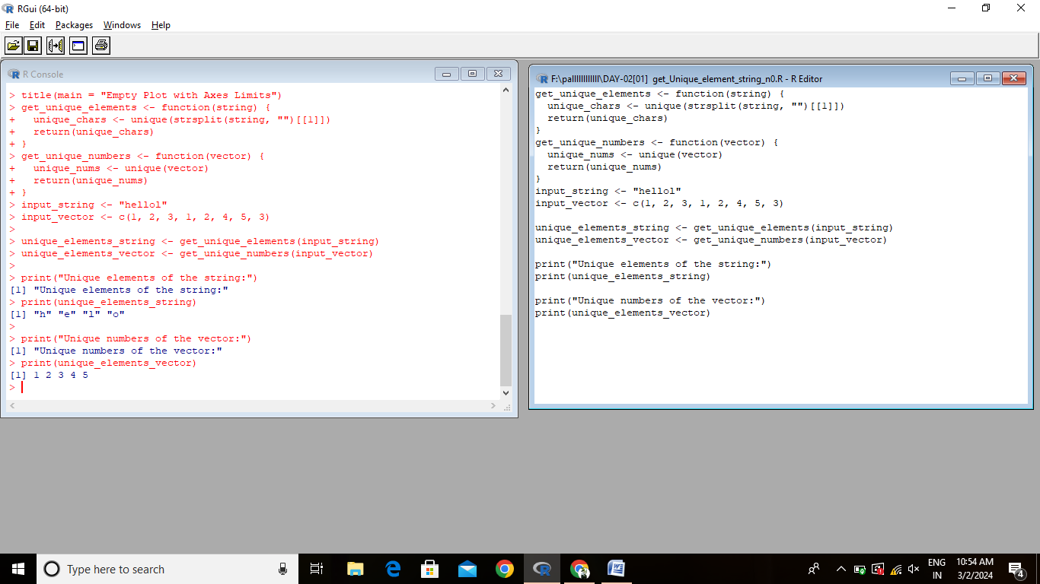

2.Write a R program to create three vectors a,b,c with 3 integers. Combine the three vectors to become a 3×3 matrix where each column represents a vector. Print the content of the matrix.

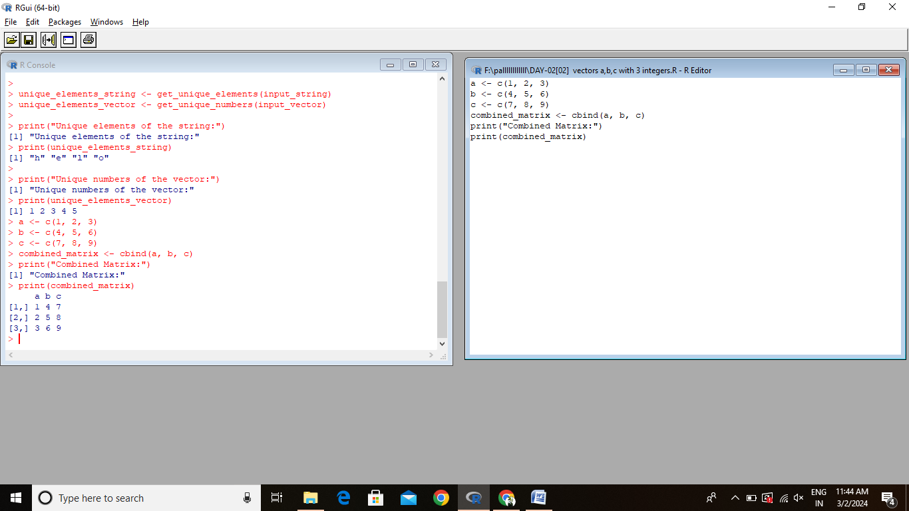

3.Write a R program to create a list of random numbers in normal distribution and count occurrences of each value.

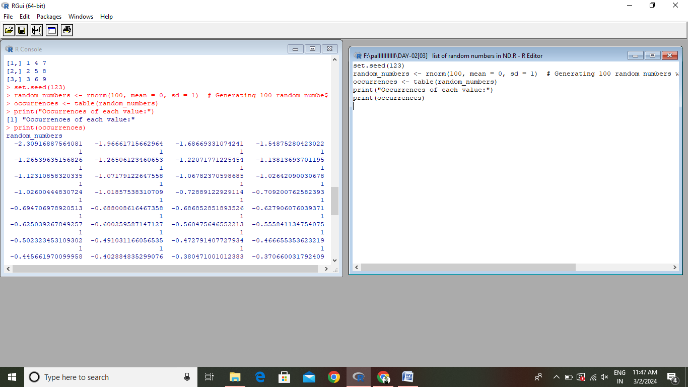

4.Write a R program to read the .csv file and display the content

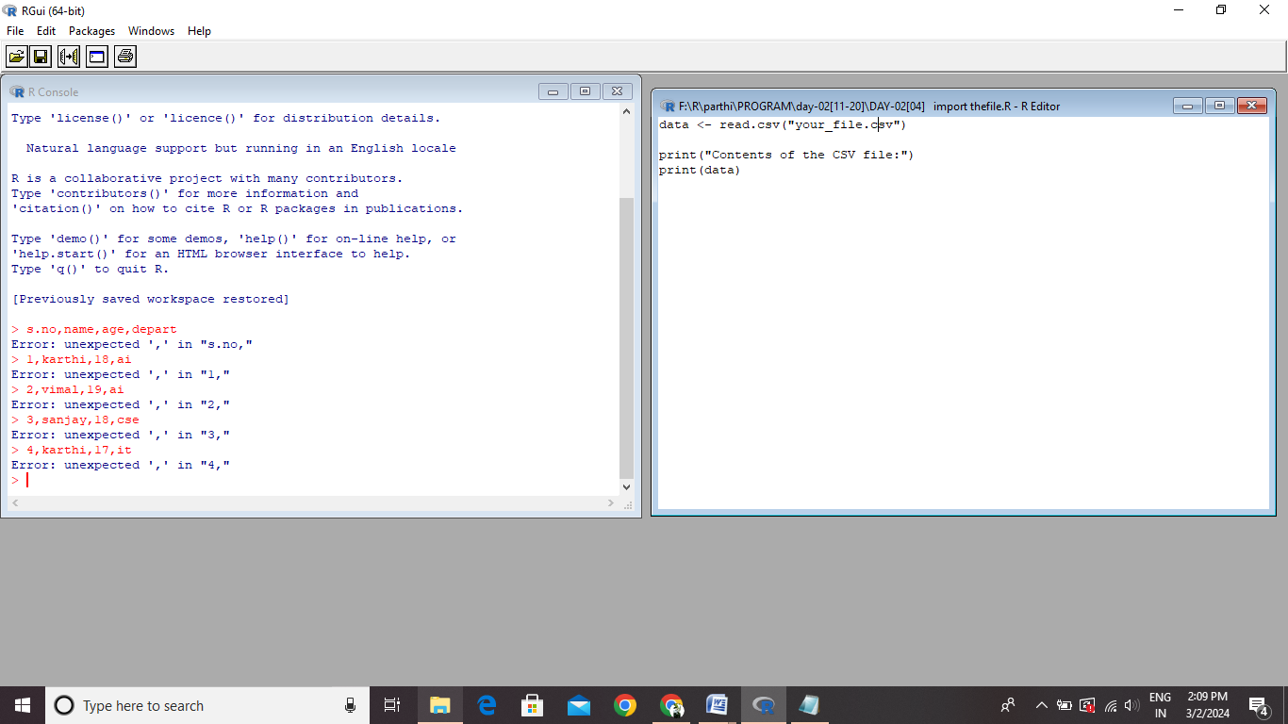

5.Write a R program to create three vectors numeric data, character data and logical data. Display the content of the vectors and their type

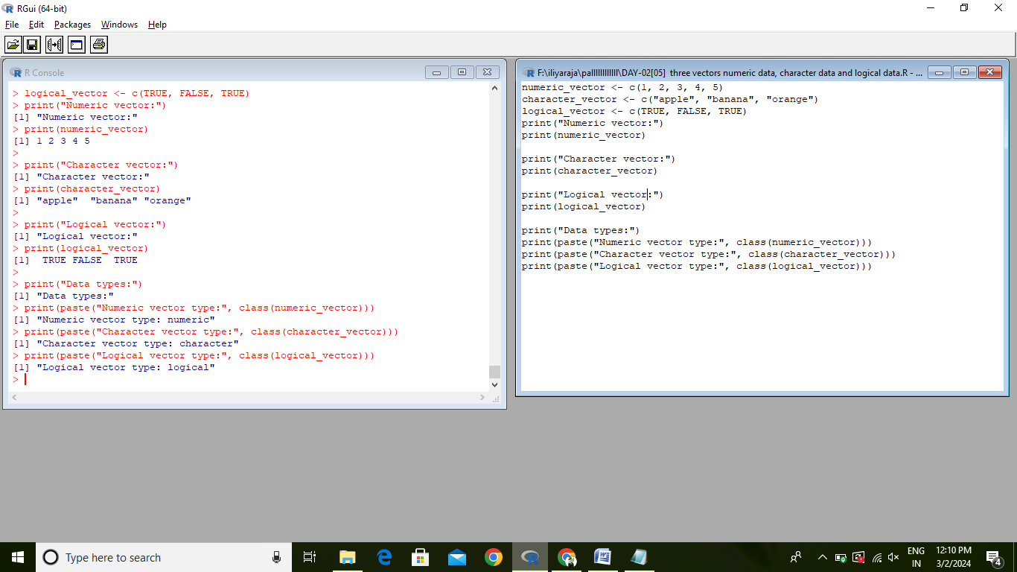

6.Write a R program to create a 5 x 4 matrix, 3 x 3 matrix with labels and fill the matrix by rows and 2 × 2 matrix with labels and fill the matrix by columns.

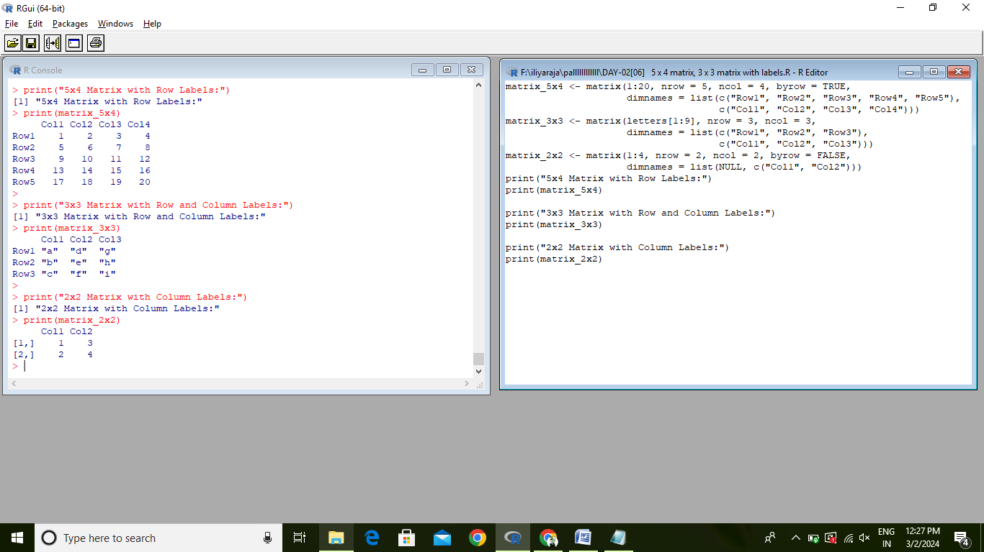

7.Write a R program to create an array, passing in a vector of values and a vector of dimensions. Also provide names for each dimension

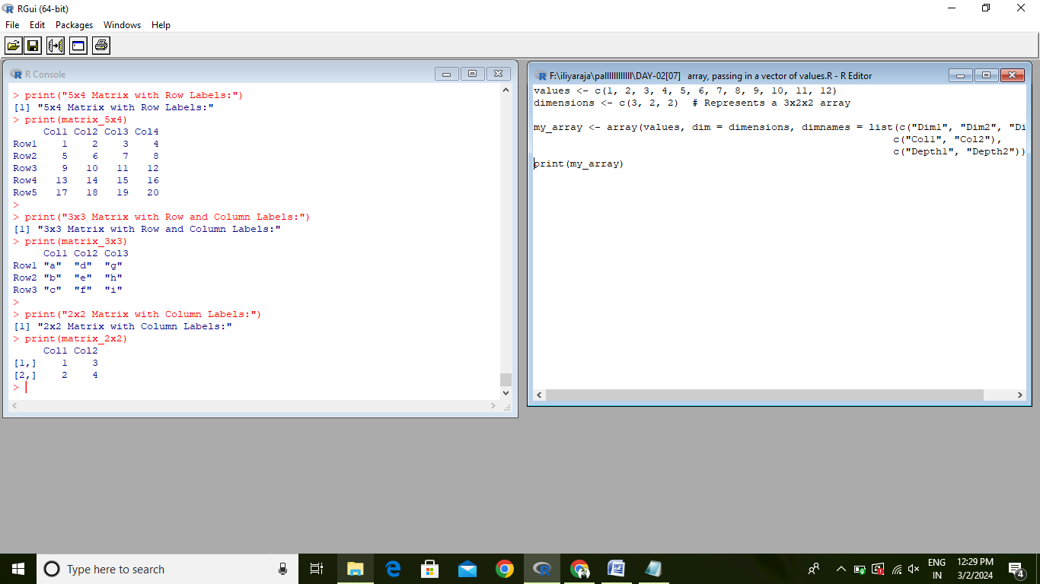

8.Write a R program to create an array with three columns, three rows, and two "tables", taking two vectors as input to the array. Print the array.

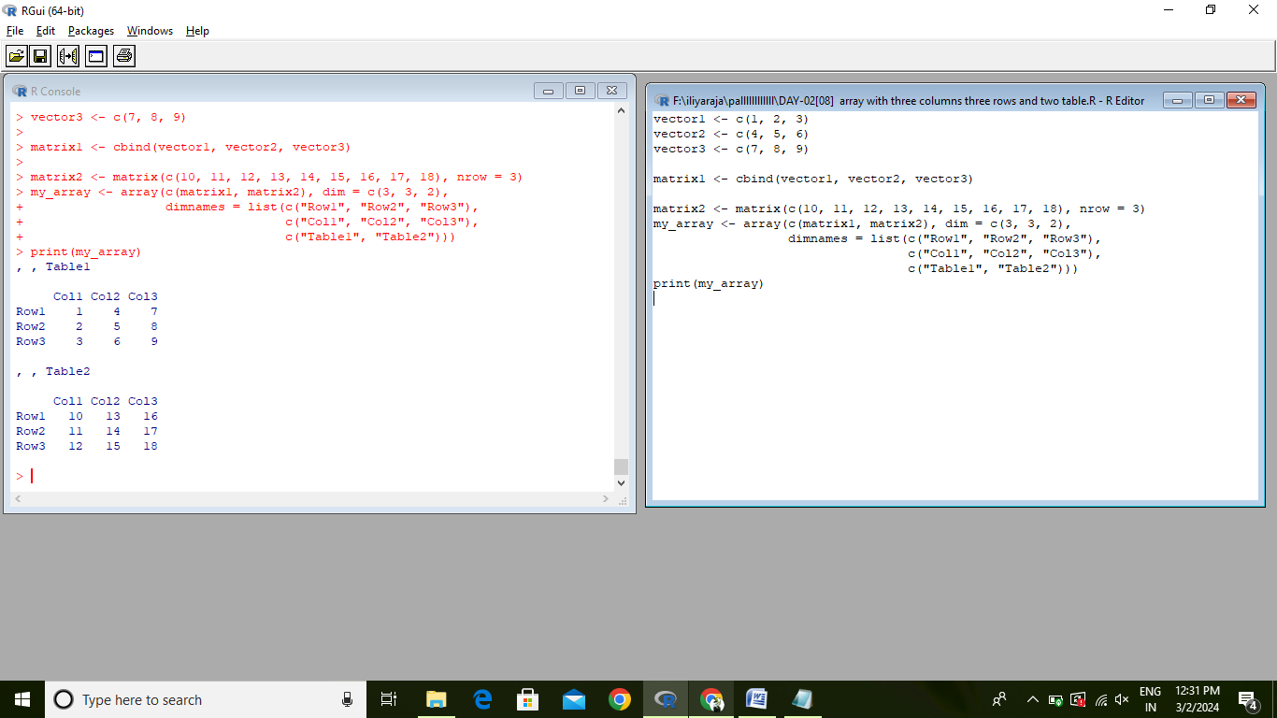

9.Write a R program to create a list of elements using vectors, matrices and a function. Print the content of the list

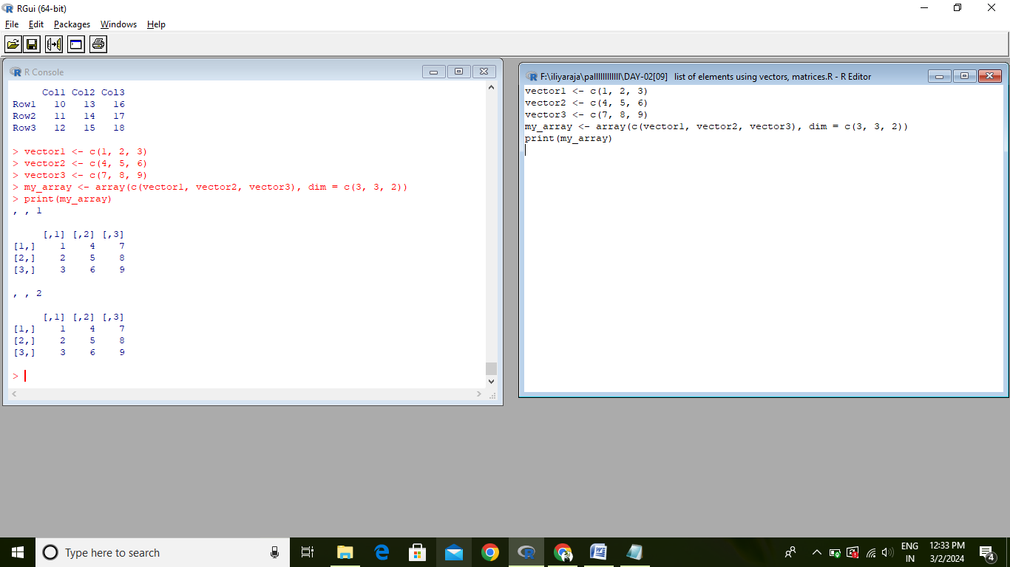

10.Write a R program to draw an empty plot and an empty plot specify the axes limits of the graphic

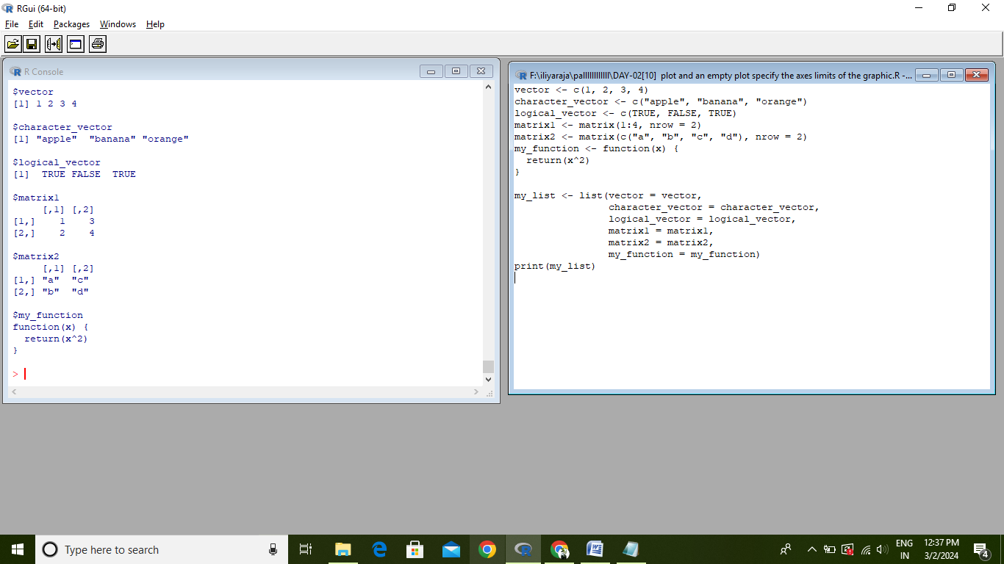

**ANALYTICAL QUESTIONS**

Consider an R script designed to analyze temperature data collected from three different cities over a week. The temperature data (in degrees Celsius) are stored in three atomic vectors as follows:

- City A: c (22, 25, 21, 23, 24, 22, 20)

- City B: c (18, 20, 19, 21, 20, 19, 18)

- City C: c (30, 32, 31,33, 34, 32, 31)

Using this data, perform the following tasks:

1. Calculate the average temperature for each city over the week.
2. Identify the city with the highest average temperature and report its value.
3. Calculate the variance in temperature for each city to assess temperature fluctuation throughout the week.
4. For each city, identify the day with the maximum temperature and report the temperature value.

Provide the R Code that performs these calculations.

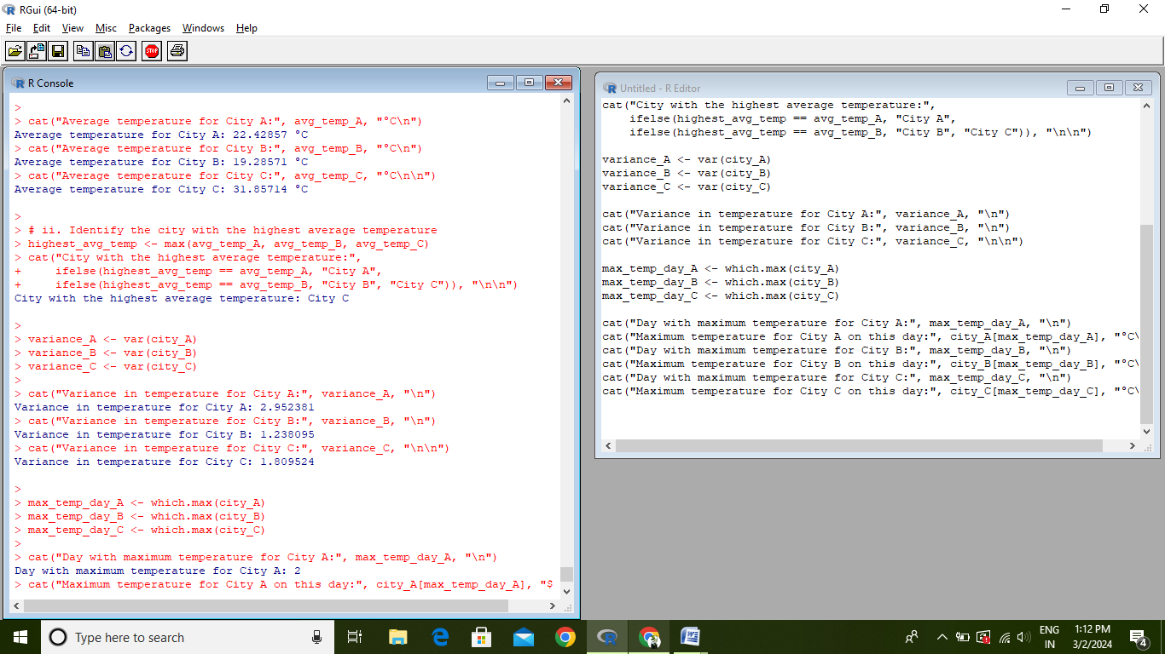

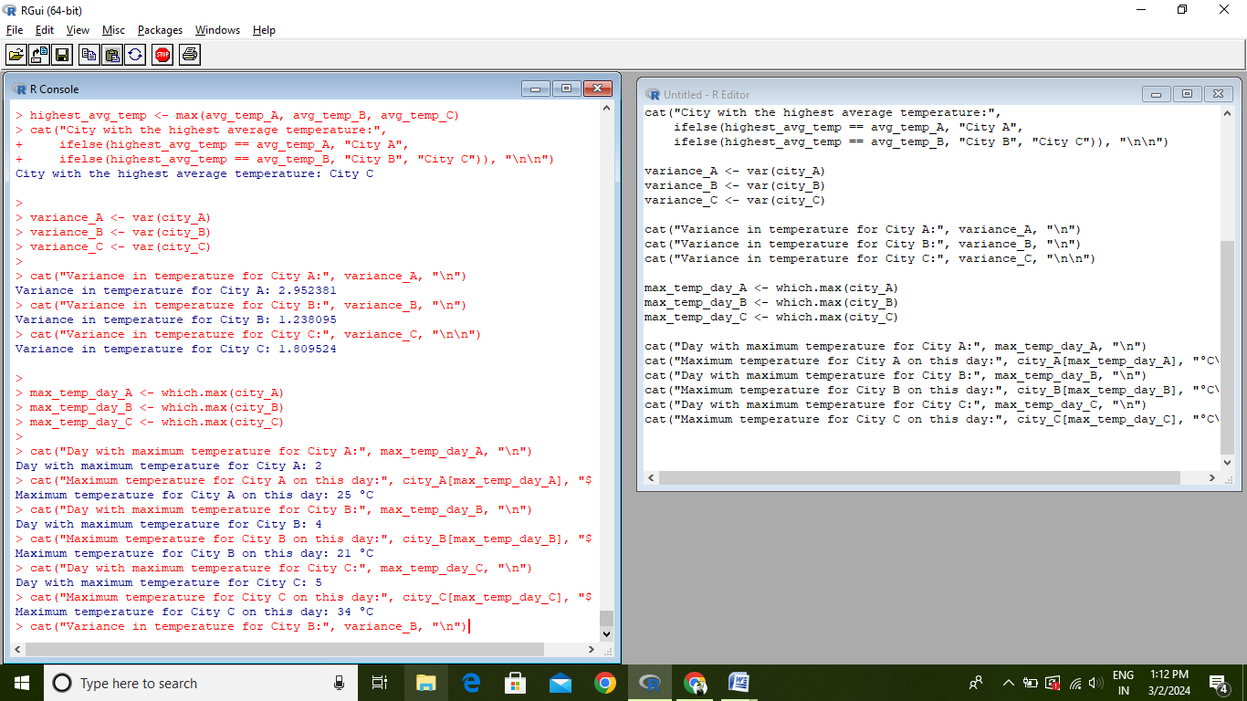

2.Create an S3 class to represent financial transactions with attributes like “amount”, “date” and “description”.

Consider the transaction

|  |  |  |
| --- | --- | --- |
| Date | Description | Date |
| 12/07/2000 | computers | 500000 |
| 13/8/2000 | Software | 200000 |
| 14/09/2000 | Home Product | 100000 |

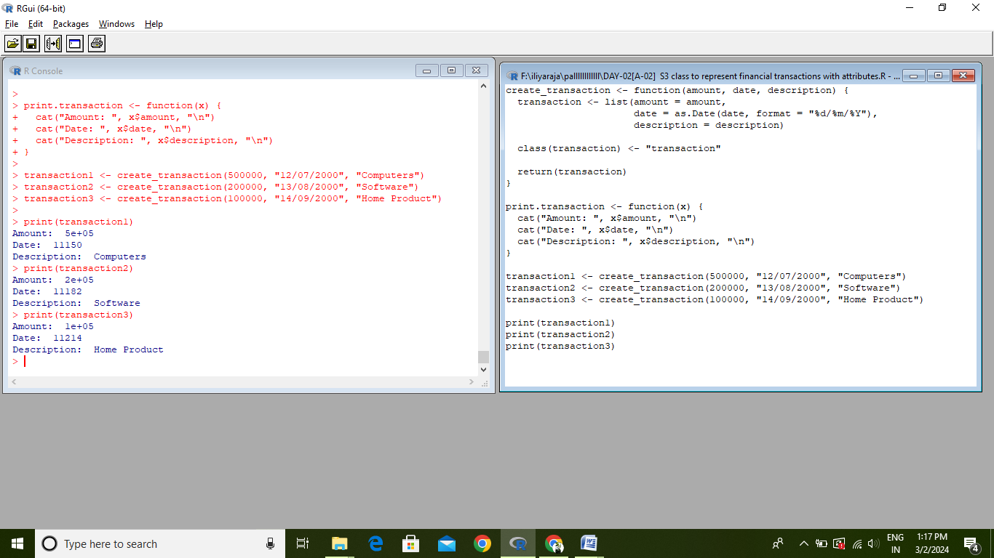

**3.** Suppose you have a dataset, 'traffic_data, collected from a busy intersection over 30 days. The dataset contains two variables:

‘day': The day of the month (1l to 30)

'accidents': The number of traffic accidents recorded at the intersection on each day

Tasks: You are asked to model the number of accidents per day using Poisson Regression, considering the day of the month as an explanatory variable to account for potential trends over time (e.g., increasing traffic towards the end of the month). Fit a Poisson regression model using 'accidents as the response variable and 'day' as the explanatory variable. Summarize the model's output and interpret the coefficient for `day'. Predict the number of accidents on the 31st day, assuming the trend continues, and report the predicted count. Provide the R code to perform these tasks.

